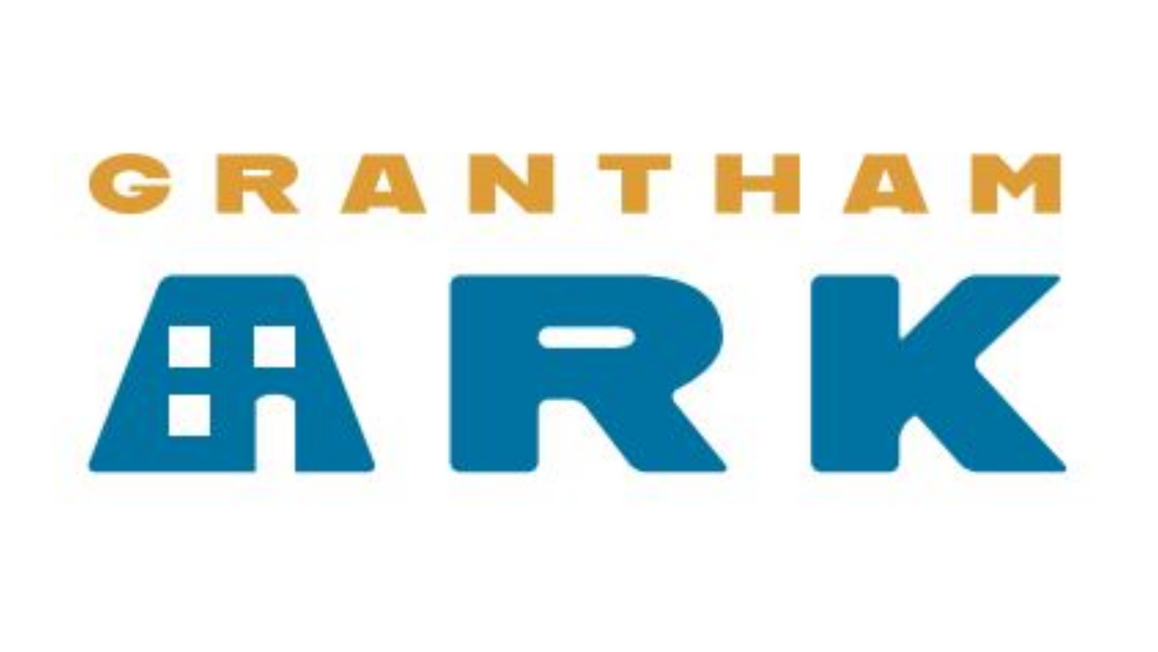
DATA PROTECTION AND PRIVACY POLICY

- Principles
Grantham Ark is committed to treating the information of individuals with utmost care and confidentiality. This policy should be read in conjunction with the Confidentiality Policy. With this policy we ensure that those engaged in the activities of Grantham Ark behave in a fair and moral manner concerning the gathering, storing and handling of data. This process will be carried out with transparency and respect towards the rights of individuals who entrust it with their information.

This policy applies to all parties who provide or use information available to Grantham Ark. Generally, it refers to anyone who is in close collaboration with Grantham Ark or acts on its behalf and may need occasional access to the data.
All individuals who act with the authority of Grantham Ark are required to adhere to this policy which is designed to protect personal data and comply with relevant data protection legislation.
Day to day data management will but overseen by those persons in a supervisory capacity. However Trustees have an obligation of organisation to ensure there is a robust Data Protection protocol and that this protocol is adhered to by checks made at least annually.
  - Grantham Ark is dedicated to the principle of all United Kingdom General Data Protection Regulation (UK GDPR)
The 7 UK GDPR Data Principles are:
      - Lawfulness, fairness and transparency
      - Purpose limitation
      - Data minimisation
      - Accuracy
      - Storage limitation
      - Integrity and confidentiality (security)
      - Accountability
Failure to comply with the principles may leave organisations open to substantial fines.

  - The UK GDPR provides the following rights for individuals:
      - The right to be informed
      - The right of access
      - The right to rectification
      - The right to erasure
      - The right to restrict processing
      - The right to data portability
      - The right to object
      - Rights in relation to automated decision making and profiling.
Grantham Ark is registered with the Information Commissioner as a controller which means that it determines what purposes personal information held, will be used for. It is also responsible for notifying the Information Commissioner of the data it holds or is likely to hold and the general purposes that this data will be used for and is governed by the Data Protection Act 2018, the EU General Data Protection Regulation (GDPR) and the Privacy and Electronic Communications Regulations 2003 (PECR). The ICO is the government body responsible for enforcing data protection law in the UK.

- Privacy
  - The UK GDPR requires organisations to be transparent about the personal data that they hold and how it is used.

  - Grantham Ark recognises that in the course of it's activities, it may be privy to data and information about individuals.

  - The UK GDPR requires organisations to provide the following information to individuals at the point that data is collected from them:
      - The identity and contact details of the organisation.
      - The contact details of the data protection officer, if relevant;
      - The purposes for which the personal data will be processed, as well as the legal basis for the processing;
      - If the organisation is relying on its legitimate interests as the lawful condition for processing, what those legitimate interests are;
      - The recipients or categories of recipients of the personal data;
      - Any transfer of the data outside the UK and the basis for such transfer;
      - The period for which data will be stored, or the criteria used to determine how long data will be retained;
      - The individual's rights to subject access, rectification or erasure of personal data, and the right to restrict processing or object to processing;
      - The right to withdraw consent to processing at any time, if the data controller is relying on consent as a ground for processing;
      - The right to lodge a complaint with the Information Commissioner;
      - Whether or not providing the data is a statutory or contractual requirement, or a requirement necessary to enter into a contract, and whether or not the data subject is obliged to provide the personal data, and the consequences of failing to provide the data;
      - The existence of any automated decision-making and meaningful information about the logic involved and the consequences of any such processing for the individual; and
      - Where data is obtained from a third party, the source of the data, including if it came from publicly accessible sources.

- UK GDPR states: Where an organisation wishes to process existing personal data for a new purpose, it must inform the individual of the reason for that further processing.

- Any information provided by an individual may be collected and processed by Grantham Ark and any person(s) who may legitimately be contracted to provide essential services e.g. Payroll services. These persons will also comply with UK GDPR legislation.

- Information is collected in a variety of ways:- application forms, CVs or resumes; obtained from a passport or other identity documents such as driving licence; from forms completed at the start of or during engagement; from correspondence; or through interviews, meetings or other assessments. In some cases personal data may be collected from third parties, such as references supplied by former employers, information from employment background check providers, information from credit reference agencies and information from criminal records checks permitted by law.

- Data is securely stored, (regardless of the format in which it is held) and internal policies and controls are in place to try to ensure that data is not lost, accidentally destroyed, misused or disclosed, and is not accessed except by those entitled in the performance of their duties.

- Grantham Ark relies on legitimate interests as a reason for collecting and processing data, it has considered whether or not those interests are overridden by the rights and freedoms of the individual.

- The UK GDPR sets no specific periods for retention of personal data. One of the key principles is that personal data should not be kept longer than is necessary for the purpose or purposes for which it is being processed and with regard to relevant legislation. Data held after the end of employment is as long as necessary dependent on the reason for the end of the employment relationship. 6 years is the guide as it satisfies HMRC guidance too.

3. Consent
- Grantham Ark will obtain the individuals consent, or find another ground on which to lawfully process data, by demonstrating that in each instance the individual was:
  - Informed of the purpose and use of their personal data
  - Given a clear explanation of how it will be treated
  - That there is a UK GDPR declaration on all relevant forms, informing individuals of this policy and outlining the reason for the data collection.

4. Purpose
- Grantham Ark needs to process personal information about different data subjects. The following list provides various purposes but is not exhaustive:
  - Process donations and gift aid claims
  - Process legacies and pledges
  - Enable supporters to fundraise for us
  - Enable supporters to participate in events
  - Manage relationships with our supporters
  - Provide supporters with information about us and the work that we do
  - Manage marketing and communication preferences of our supporters
  - Recruit and employ members of staff
  - Recruit and manage volunteers
  - Fulfil our legal and governance obligations as a registered charity and company

5. Breaches
- The UK GDPR introduces a duty on all organisations to report certain types of personal data breaches to the relevant supervisory authority. This must be done within 72 hours of becoming aware of the breach, where feasible. If the breach is likely to result in a high risk of adversely affecting individuals’ rights and freedoms, they must also be informed without undue delay. Organisations must also keep a record of any personal data breaches
- As with any security incident, Grantham Ark will investigate whether the breach was a result of human error or a systemic issue and see how a recurrence can be prevented – whether this is through better processes, further training or other corrective steps.

Review date January 2024

