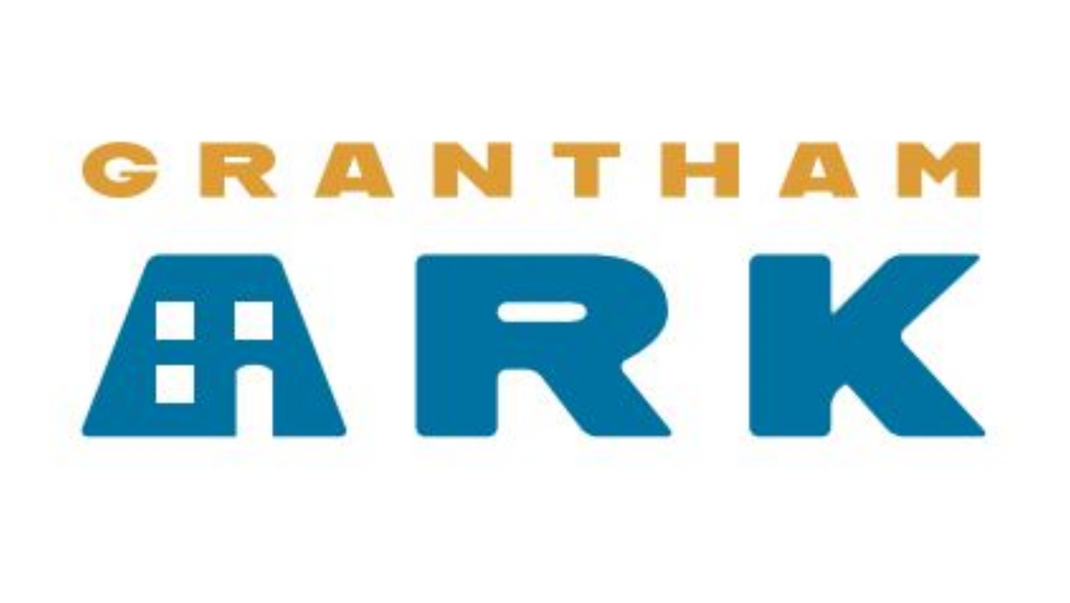
ADULT SAFEGUARDING & VULNERABLE ADULT POLICY

- Aims
This policy has been drawn up in recognition that there is an ever-present risk of abuse happening to vulnerable adults. It is our duty to prevent abuse and to take effective action when abuse is suspected or disclosed. Abuse is unacceptable in all circumstances. This policy sets out the steps that Grantham Ark takes to safeguard Guests who are at risk of abuse and neglect and the responsibilities of all associated in whatever capacity with Grantham Ark in cases of suspected abuse or neglect.

- Good Practice
The best defence against abuse is the strength of values incorporated in the Grantham Ark culture. The Grantham Ark Trustees believe that all Guests are entitled to be treated with dignity, courtesy and respect regardless of their age, race, gender, gender orientation or ability. Safety is embedded within good sound practice and the growing ability of Guests to protect themselves, make their views known and be listened to.

- Safeguarding Lead
The designated Safeguarding Lead at St Wulfram's will also be available to support Grantham Ark. They ensure all those working with the Grantham Ark are subject to appropriate checks and all safeguarding issues are appropriately recorded and dealt with. Advice can be sought from the Diocese of Lincolnshire.

- Recruitment and training
Trustees will exercise proper care in making appointments to ensure that the attitudes and skills of appointees ensure the safety of vulnerable adults. In addition the Trustees will support those engaged with Grantham Ark's activities with the appropriate resourcing and training to ensure their suitability to work with vulnerable adults.

- Vulnerable Adult
The statutory definition of vulnerable adults is set out in the Safeguarding of Vulnerable Groups Act 2006. That Act as amended by the Protection of Freedoms Act 2012 does not define homeless adults per se as Vulnerable Persons. However, Grantham Ark considers that most homeless persons are vulnerable and appropriate safeguarding measures should be undertaken to minimise risks to them. Whilst the paramount consideration is protection of the Guests, it should also be borne in mind that those engaged with Grantham Ark may include adults who need protection.
For the purposes of this policy a vulnerable adult is defined as
  - a person of 18 years and over who is, or may be, eligible for community care services by reason of mental or other disability, age or illness; and
  - who is or may be unable to take care of him/herself, or
  - unable to protect him/herself against significant harm or exploitation.

- Abuse
Abuse is a violation of an individual's human or civil rights by any other person or persons. It is a single or repeated act or omission, occurring within a personal or other close relationship where there is an expectation of trust, which causes harm to a vulnerable adult. Abuse can take many forms:
  - Physical - This could be someone hitting, kicking, pulling hair, pinching or shaking you, or being given too much or too little medication. This could also be assault.
  - Financial - This could be someone stealing from you, or forcing you to pay for other people’s things, or when you don’t have a say in how your money is being spent. This could also be theft or fraud.
  - Emotional - This could be someone calling you names, bullying you, or treating you like a child, being ignored, or blamed for things that you did not do, being shouted at, or threatened.
  - Sexual - This could be being touched, or forced to touch someone else, or made to have sex with someone when you don’t want to. This could also be rape or sexual assault.
  - Neglect - This could be if you are hungry, cold, do not have clean clothes to wear, or are denied access to things that you need.
  - Discrimination - When you are treated unfairly because of your race, age, gender, gender orientation, disability, sexuality or background.

The Need for Firm Management ensures that by maintaining a calming and welcoming ambiance, the operation of the Grantham Ark does not become lax and thus lead to situations in which violence and other forms of abuse emerge. Experience shows that such laxity can lead to a total break down and thus closure to the detriment of the Guests. It is therefore expected that all those engaged with Grantham Ark must be fully appraised of the entirety of it's Policies and Procedures and apply them consistently.

- Prevention and Risk Management
Grantham Ark aims to control the risk of abuse and target the causes and opportunities for abuse and neglect. These include:
  - Communication with those engaged with the work of Grantham Ark about the nature of abuse and the Adult Safeguarding Policy.
  - Embedding the principles of safeguarding into all Grantham Ark's practices.
  - Robust risk assessment for every Guest by way of the referral process before they stay at any of the properties managed by Grantham Ark.

Prevention strategies are specifically targeted at those working with or otherwise engaging with adults at risk. Prevention Strategies include:
  - Recruitment – Disclosure and Barring Service (DBS) checks on all those directly involved with Guests to ensure that any convictions indicated do not present a risk to the safety of the Guests. Other persons are subject to references prior to allocation to activities.
  - Policies and Procedures actively followed by those engaged with Grantham Ark reinforced through expectations by rules for conduct and practice and particularly in respect of confidentiality and procedures for the prevention of violence.
  - Support and information will be received from their allocated supervisor. Training will be offered and information on policies and procedures will be available to all.
  - All are responsible for reporting concerns, disclosures or possible indications of abuse to the Safeguarding Lead without delay.
  - Information about abuse must never be withheld intentionally as failure to disclose may have an influence on the future safety of an individual.
  - Disclosures and concerns should not be treated as confidential.

  - Remember that those engaged with Guests must never promise to keep secrets for a Guest. Do not be alone with a Guest unless this is absolutely unavoidable for operational reasons and then only in a communal space where CCTV is located and never in the Guest's room. Anything heard or seen which causes concern should in the first instance be reported to the allocated supervisor who in liaison with the Safeguarding Lead will consider referring information on to the most appropriate agency.

8. Use of Images
Grantham Ark recognizes that protecting and upholding the rights of adults includes social media and other promotional materials. Images will only be used where Guests give their informed consent. The following principles will be adhered to:
    - Images will not be taken without consent from the subject
    - Grantham Ark will explain to the Guest how and where the images will be used and will adhere to this.
    - Images used on the Grantham Ark website and social media pages will not be used on personal social media pages.
    - External media, television crews and journalists must obtain informed consent from Guests before the use of any image.

Review: January 2024

